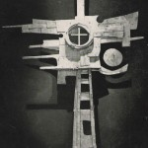
STANDING ORDER FORM
To the Manager
Name of Bank
Address of Bank
I/we hereby authorise and request you to debit my/our
Account Name*
Account Details
Sort Code |  | Account Number |  | Amount |  |  |  | Frequency (delete as appropriate)
 |  |  |  | £ |  |  |  | Monthly / Weekly
Beginning Date |  | End Date (delete as appropriate) | Number of Payments
 |  | /Until I cancel
And Credit
All Saints & Martyrs PCC
Sort Code |  | Account Number
01-05-63 |  | 41075668
Quoting Reference
 |  |  |  |  |  | (Your Name)
Signed
Block Capitals
*Please ensure that the actual name on/of the account is included in this box so that we can accurately match your payment to our records.

